MobileDeluge User Guide

1. Introduction

MobileDeluge is an over-the-air programming tool developed based on Deluge.

1.1 Directory structure

/Deluge:

Code from the original Deluge, with very little modification on “ObjectTransferP.nc” to add led blinking when transmitting the code image.

/SimpleDrip:

A replacement of the original Drip.

/SimpleGateway:

A general gateway to control the reprogramming process

/tests:

Some test applications for SimpleDrip (use it with Deluge).

/Reprogrammer

MobileDeluge control layer, on top of Deluge.

.../DelugeBase

The MobileBase for MobileDeluge.

1.2 Reprogrammer

[TODO]

1.3 Gateway

[TODO]

1.4 SimpleDrip

[TODO]

1. Prerequisite

Before Deluge (and hence MobileDeluge) can be used, a few tools must be set up.

**Note**: the following commands are for Linux based systems. If you use Mac, the commands can be slightly different. But the tools to be installed are the same.

2.1 Install a few python scripts

Run the following commands in the terminal. Suppose TinyOS root directory is TOSROOT (i.e., /……/tinyos-2_1_2).

% cd $TOSROOT/tools

% ./Bootstrap

...

% ./configure

...

% cd tinyos/misc

% make; make install

If you get any errors about “aclocal” or similar, you will need to install “autoconf” and “automake” tools by running the following command on terminal.

% sudo apt-get install automake autoconf

2.2 Install Python serial tool

For Linux (e.g. Xubuntu, Ubuntu) you should already have this tool installed. If not, run this command on terminal.

% sudo apt-get install python-serial

For Windows + Cygwin, download the package from this link:

<http://pyserial.sourceforge.net/>

and install.

2.3 Compile Bootloader for different mote platforms

In Deluge, Bootloader is running on each mote to reprogramming itself. It loads the new image from the flash memory to the memory, and reboots the mote. After this process, the mote is running the new application. Run the following commands in terminal to compile the Bootloader for each mote platform ($TOSDIR is: /……/tinyos-2_1_2/tos):

% cd $TOSDIR/lib/tosboot

% make micaz # for micaz platform

% make telosb

% make iris

After all these are done, Deluge (and MobileDeluge) should work properly. If interested, please refer to this link for more information:

<http://tinyos.stanford.edu/tinyos-wiki/index.php/Deluge_T2>

1. Quick Start

3.1 Preparation

* Use **MicaZ** mote as the DelugeBase.
* Make sure the target motes have voltage higher than **2.7** Volts.
* A TelosB mote as the sniffer (not necessary but preferred).
* Start MobileGateway.

**3.1.1 Install DelugeBase**

Suppose the serial port of Mib520 board is /dev/ttyUSB2 and /dev/ttyUSB3.

Go to /MobileDeluge/Reprogrammer/DelugeBase and install it to the MicaZ mote.



**3.1.2 Prepare the new application image**

Go to the folder of the new application. For example, suppose the folder is: aswp_app_eer_v4_2/Apps/Motes_telosb/telosb_regular_mps2, compile the application and inject it to the DelugeBase.



Then, use the following command to inject the new application.

% tos-deluge serial@/dev/ttyUSB3:57600 –i 1 build/telosb/tos_image.xml



You can see the process of the injection as following:

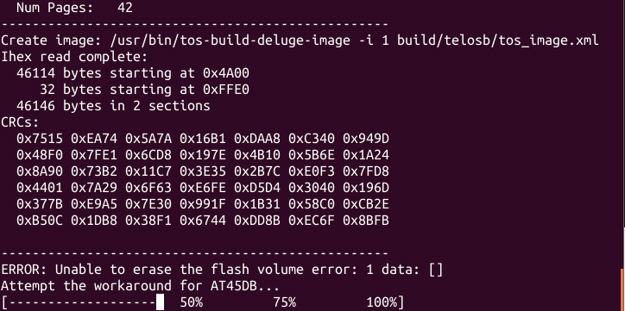

When finished, you can see something like this:

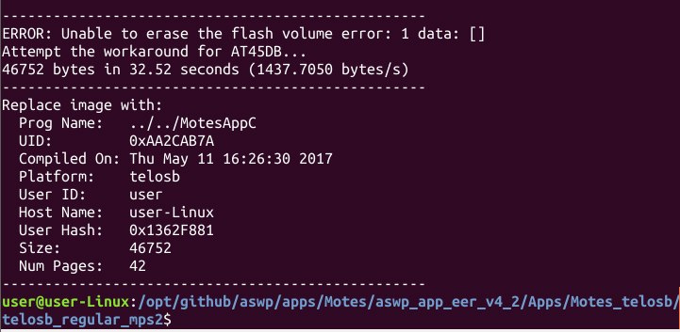

**3.1.3 Prepare the sniffer**

(Suppose the serial port of the TelosB mote is /dev/ttyUSB1)

Sniffer can hear all the radio transmission in the environment. It can be used to monitor the dissemination process of the application from DelugeBase and the target mote.

First, build the C serial forwarder in TinyOS (i.e., TinyOS serial library libmote.a):

% cd $TOSROOT/support/sdk/c/sf

% ./bootstrap

% ./configure

% make

Go to aswp_app_eer_v4_2/Sniffer, edit the value of SNIFFER_CHANNEL in Makefile to select a channel to be monitored. In the following we monitor channel 13.



Install this application to a TelosB mote:



Then, run the following command to start the parser of sniffer application:



**3.1.4 Start MobileGateway**

Go to /MobileDeluge/simpleGateway/ and run:

% java –jar MobileGateway_v2.3.4.jar –comm serial@/dev/ttyUSB3:57600 13

## usage: java –jar gatewayjar.jar –comm [serial source] [new channel]

When it starts successfully, you will see the following:

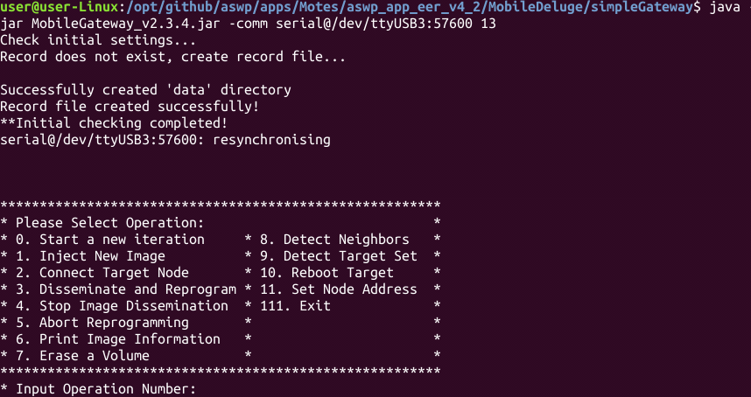

Now we can start to use the MobileDeluge tool to reprogram the motes and discover the motes nearby.

3.2 Detect neighbors

In the MobileGateway terminal, enter **“8”** and you will see the node nearby:

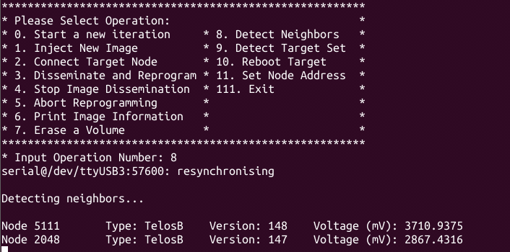

Wait about 10 seconds to let all nearby motes reply. Press **Enter** to show the menu again.

You can also use option **“9”** to detect specific target motes (use “**space**” to separate mote IDs):

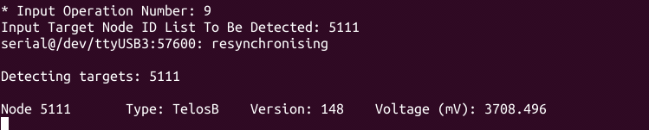

If you see nothing, then you can reboot the DelugeBase and the MobileGateway, and try again.

3.4 Connect to the target motes

Input option **“2”** to connect to the target motes for programming. Similar to option **“9”**, use “**space**” to separate multiple target IDs:

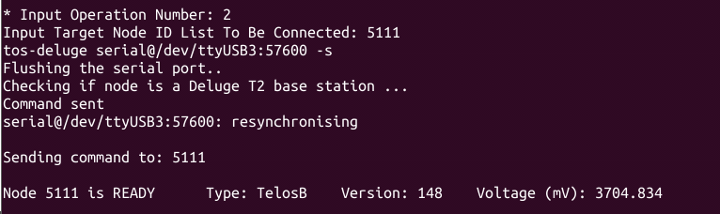

If the target ID returns **READY**, then we can start to disseminate the new application.

In the sniffer terminal, you can see some packets showing up:

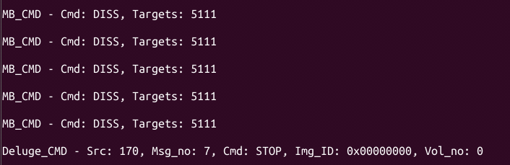

3.5 Dissemination and reprogramming

Input option **“3”** to start disseminate the new application to the target motes.

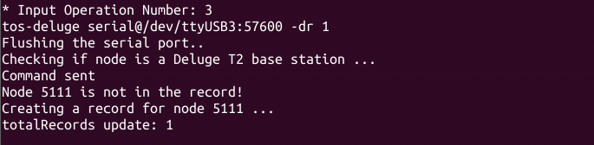

You can see the packets flushing in the sniffer terminal. In the following, the application has 46 pages, and DelugeBase has transmitted 38 pages.

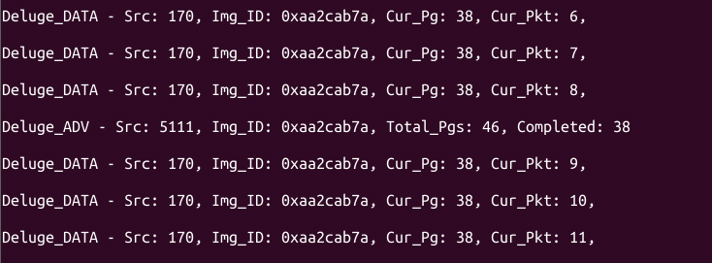

You will also see the LEDs on the DelugeBase flashing during the dissemination. When the flash stops, the dissemination is completed.

**3.6 Stop further dissemination**

This is a critical step after every dissemination. When dissemination is finished, the STOP command must be sent. Issue command **“4”**:

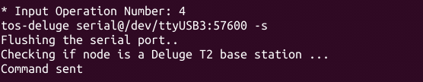

After this, you can use command “**8**” (detect neighbors) again to check the application version in the mote. As we can see below, mote 5111 now is running application version 42:

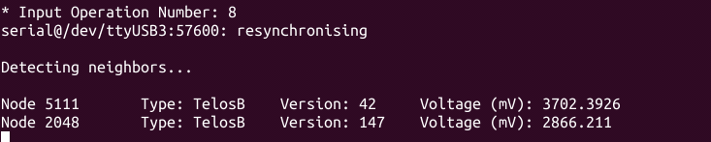

3.7 Abort wrong targets

Input **“5”** to abort one or more target motes if any of them are wrongly selected (after option **“2”**). Use **“space”** to separate multiple IDs. Input “**a**” to abort all motes.

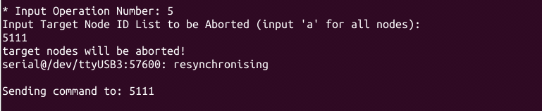

There will be no reply from the aborted mote. So wait for a few seconds and press **Enter** to return to the main menu.